Each WIMEK PhD candidate develops an individual Training and Supervision Plan (TSP). This plan is tailor-made for your personal development with the aim of becoming a well-qualified independent researcher and professional in your field. When you have fulfilled all the requirements for the TSP at the end of your PhD (see requirements at https://sense.nl/training-and-supervision-plan/ and in Section 5), you will obtain the WIMEK-SENSE Diploma.

Overview of TSP trajectory

Within 6 months after the start of your PhD project  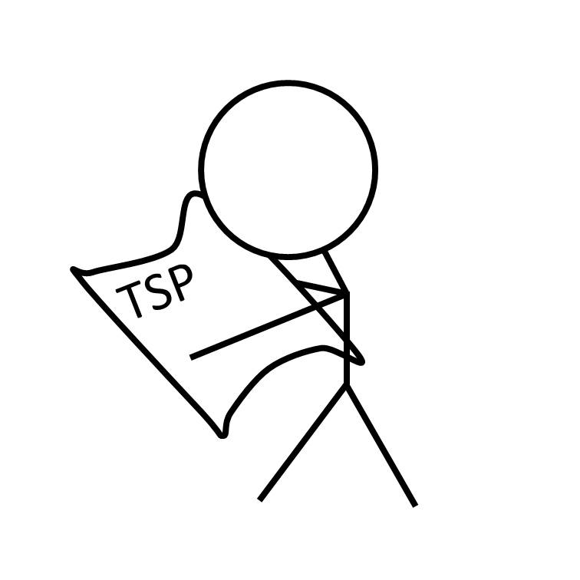  Upload your training and supervision plan (TSP) for approval to WIMEK in Hora Finita: https://horafinita.wur.nl/. With an approved TSP you are eligible for a reduced fee for WIMEK, WGS and SENSE courses and activities. | Throughout your PhD  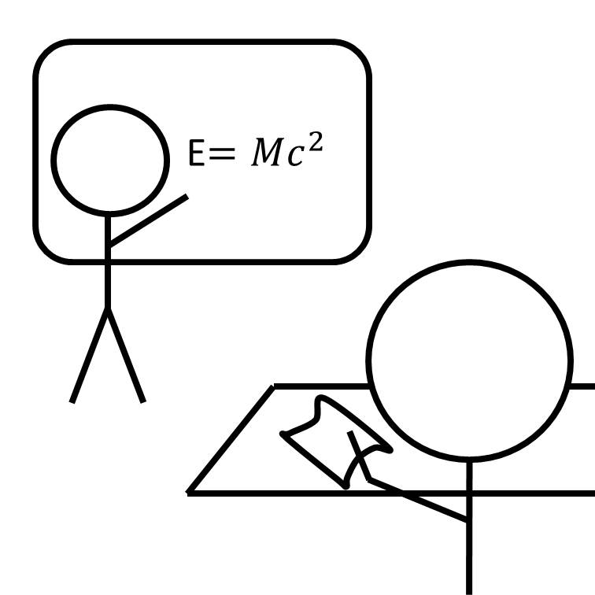  Obtain skills and experience by taking courses and training activities. Keep track of your activities by updating this form. | At least 15 weeks before the expected defence date  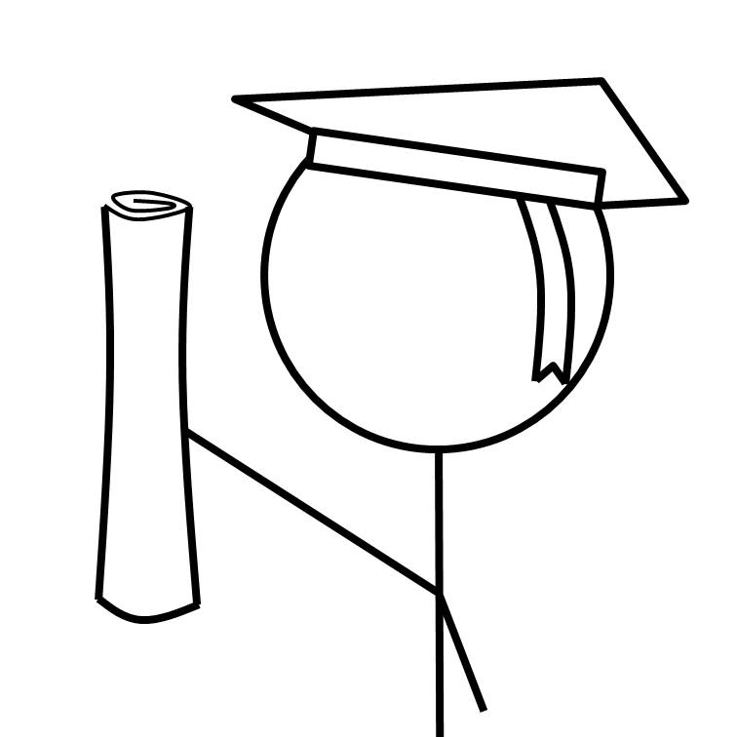  Finalise this form with all the activities you have successfully completed and apply for the WIMEK-SENSE diploma by submitting the final version of this form to WIMEK: WIMEK@wur.nl

The TSP is divided into five parts:
- General Information
- Supervision Plan (not applicable for Diploma application)
- Self-Assessment (not applicable for Diploma application)
- Reflection on Self Assessment (not applicable for Diploma application)
- Training & Education Plan

- General Information


PhD candidate information
Full name
(as will be shown on Diploma)
Date of birth
Place & country of birth
University/Institute
Research group


PhD project information - also fill out this part when you apply for TSP approval
Project title
Project summary
Consent: I give permission to publish the project summary in the Current Research module on the SENSE website (https://sense.nl/research/) | ☐ YES  ☐ NO  Date:


WIMEK-SENSE Diploma application
only fill out this part when you apply for your WIMEK-SENSE Diploma
at the end of your PhD research

Email address (where we can reach you also after graduation)
Graduation date and time
Name First Promotor
Other supervisors
Postal Address Promotor
City of Graduation
Thesis title
Thesis summary (max. 150 words)

- Supervision Plan

It is important to have the same expectations of the supervision as your supervisors. Such as:
- Amount of time spent by supervisors on your PhD project,
- Who is involved in which chapter or with which publication,
- Number of meetings to evaluate the progress of the PhD project.
The Supervision Plan is an agreement between the PhD candidate and the supervisors, therefore, both parties must agree with the content and with the specified arrangements. It is advised to evaluate your supervision plan with your supervisors at least once a year, but preferably every 6 months. Check if the agreements still work well, or should be adjusted.

Supervisor  First name Surname |  | Role supervisor ¹ | Frequency  of meetings²  (hrs/month) | Format meetings ³  (Face-to-face, Skype, email, other...) | Review on performance ⁴  (times/year)
Choose role
Choose role
Choose role
Choose role
Choose role
Choose role
Choose role
Choose role
Choose role
Choose role

Please, discuss your Training and Supervision Plan with all your supervisors and make sure you all agree with this plan:

☐ I declare that my supervisors agree with this Training and Supervision Plan, Click here to enter a date

Please, read the Netherlands code of conduct for Research Integrity⁵ ⁽https://www.vsnu.nl/en_GB/research-integrity); and sign the declaration below :

☐ I will act according to The Netherlands code of conduct for Research Integrity, Click here to enter a date

- A supervisor can have two roles: both Promotor and Daily supervisor, or both Co-promotor and Daily supervisor
- Number of hours per month that you will meet with your supervisor
- Type of format and devices that will be used for the meetings
- Number of times per year that you and your supervisor monitor the progress of the project and your performance.
- Please read the whole code (the pdf; and not just the explanation on the VSNU website)
- Self-Assessment

Research Skills & Techniques
Hardly or Slightly developed |  | Aim to develop? (y/n) | How? Course / activity

The training and education activities can be assorted by four PhD competency categories. For each category several descriptions of competencies are listed, for which you can set your current level. The self-assessment gives an overview of competencies that are required to become a competent independent researcher and help you identify which competencies you can develop further. Please, assess your current level of development for these competencies.

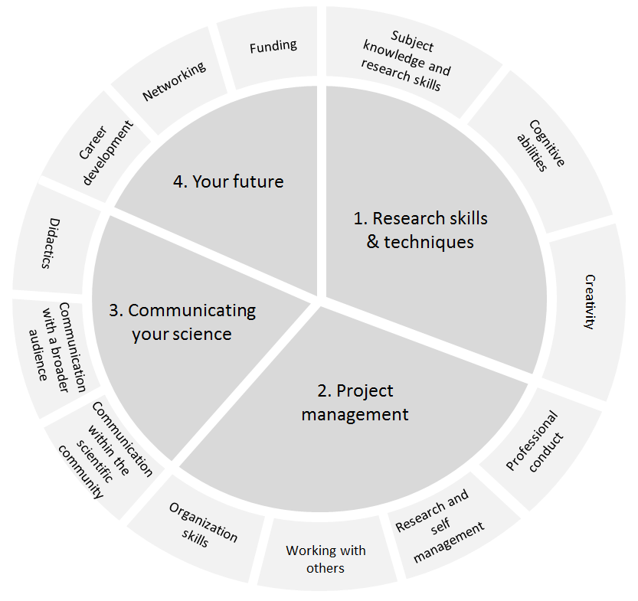
Research Skills & Techniques
How well-developed is your competency to...
Subject knowledge and research skills | Hardly developed | Slightly developed | Adequately developed | Strongly developed
.. identify and understand research problems? | ☐ | ☐ | ☐ | ☐
.. be informed of recent advances in your field? | ☐ | ☐ | ☐ | ☐
.. appropriately apply research methodologies and techniques? | ☐ | ☐ | ☐ | ☐
.. identify appropriate sources of relevant information? | ☐ | ☐ | ☐ | ☐
.. use information technology appropriately for database management, recording, and presenting information? | ☐ | ☐ | ☐ | ☐
Cognitive abilities
.. critically evaluate research findings? | ☐ | ☐ | ☐ | ☐
.. work independently and to be self-reliant? | ☐ | ☐ | ☐ | ☐
.. be flexible and open to alternative approaches to problems/tasks? | ☐ | ☐ | ☐ | ☐
Creativity
.. develop original research questions? | ☐ | ☐ | ☐ | ☐
.. produce critical and independent ideas? | ☐ | ☐ | ☐ | ☐
.. develop sound theoretical concepts? | ☐ | ☐ | ☐ | ☐

Possible ways to develop these competencies further can be activities such as:
- Taking in-depth PhD courses or advances MSc courses
- Conducting an (extended) literature study
- Taking courses on information literacy
- External research skills training, for example in the use of specific equipment
- Writing your own PhD proposal
- Writing a detailed research set-up
- Participation in PhD discussion groups / research cluster
- Writing scientific articles
- Reviewing manuscripts that are submitted for publication in scientific peer-reviewed journals
Project management
How well-developed is your competency to...
Professional conduct | Hardly developed | Slightly developed | Adequately developed | Strongly developed
.. apply the Netherlands Code of Conduct for Scientific Practice when doing research? | ☐ | ☐ | ☐ | ☐
.. openly discuss the integrity of fellow researchers? | ☐ | ☐ | ☐ | ☐
.. assess the integrity of your own research by actively asking others for feedback? | ☐ | ☐ | ☐ | ☐
Research and self-management
.. set SMART (Specific, Measureable, Attainable, Relevant, and Time-bound) research goals? | ☐ | ☐ | ☐ | ☐
.. effectively prioritise activities? | ☐ | ☐ | ☐ | ☐
.. ask for help on time and when appropriate? | ☐ | ☐ | ☐ | ☐
Working with others
.. work in multidisciplinary and transdisciplinary teams? | ☐ | ☐ | ☐ | ☐
.. position your research in a broader multidisciplinary context? | ☐ | ☐ | ☐ | ☐
.. actively communicate with researchers from other disciplines? | ☐ | ☐ | ☐ | ☐
..contribute effectively to teams by knowing how the way you behave affects the success of others and the group? | ☐ | ☐ | ☐ | ☐
.. link your research to societal issues in co-creation with stakeholders? | ☐ | ☐ | ☐ | ☐
Organisation skills
.. effectively organise meetings? | ☐ | ☐ | ☐ | ☐

Possible ways to develop these competencies further can be activities such as:
- Taking courses on ethics, project and time management
- Active participation in the introductory SENSE PhD course A1 (mandatory)
- Involve stakeholders in your research set-up
- Membership of (SENSE) PhD council, scientific board, or committee
- Organising PhD days, workshops, sessions at conferences and symposia
Communicating your science
How well-developed is your competency to...
Communication with the scientific community | Hardly developed | Slightly developed | Adequately developed | Strongly developed
.. adequately present research outcomes for users in academics? | ☐ | ☐ | ☐ | ☐
.. write clearly and in a style appropriate to purpose in the English language? | ☐ | ☐ | ☐ | ☐
.. constructively defend research outcomes at seminars? | ☐ | ☐ | ☐ | ☐
Communication with a broader audience
.. adequately present research outcomes for the general audience? | ☐ | ☐ | ☐ | ☐
.. communicate your own research in a way that contributes to the public understanding of science? | ☐ | ☐ | ☐ | ☐
.. communicate your research effectively in different (social) media? | ☐ | ☐ | ☐ | ☐
.. inspire and convince the audience with your presentation? | ☐ | ☐ | ☐ | ☐
Didactics
..effectively support the learning of others when involved in teaching, mentoring, or demonstrating activities? | ☐ | ☐ | ☐ | ☐

Possible ways to develop these competencies further can be activities such as:
- Conducting the A2 ‘Research in context’-project (mandatory)
- Giving oral and poster presentations at conferences
- Taking courses or workshops on ‘From Science to Practice’, ‘Achieving Sustainable Development’, ‘Action Science’
- Conducting activities on the science-policy interface
- Writing scientific articles
- Taking courses on scientific or academic writing, presentation skills, communication with the media, policy and public, intercultural communication
- Writing popular articles / newsletter articles
- Maintaining a research blog
- Taking didactic courses
- Teaching activities, for example supervising MSc students, giving lectures, developing short courses

Your future
How well-developed is your competency to...
Career development | Hardly developed | Slightly developed | Adequately developed | Strongly developed
..identify your own training needs based on your own strengths and weaknesses, and identify your career goals? | ☐ | ☐ | ☐ | ☐
.. promote your personal qualifications and skills, e.g. through effective CVs and social media use? | ☐ | ☐ | ☐ | ☐
Networking
..build, maintain, and use a network of people who are interesting or useful for achieving your (career) goals? | ☐ | ☐ | ☐ | ☐
.. adequately present research outcomes for users in the commercial sector? | ☐ | ☐ | ☐ | ☐
.. know how to create or improve your visibility among interesting parties? | ☐ | ☐ | ☐ | ☐
Funding
..write research proposals in a way that is attractive for funding institutions? | ☐ | ☐ | ☐ | ☐
.. how to write a business plan to start as entrepreneur? | ☐ | ☐ | ☐ | ☐

Possible ways to develop these competencies further can be activities such as:
- Taking future career courses, such as career orientation, professional skills courses
- Taking courses on networking and CV building
- Use social media for research (related) purposes
- Writing popular articles / newsletter articles
- Giving oral and poster presentations at non-scientific meetings
- Taking courses on writing grant proposals
- Training on entrepreneurship

- Reflection on Self-Assessment

In this reflection, you will evaluate your self-assessment and identify the competences that you want to develop further. Next, think of ways how can you improve these competences, what type of courses, training or other activities you need (some possible ways are listed below each competences category). Evaluate for each of the four PhD competency categories for which questions you have answered ‘Hardly developed’ or ‘Slightly developed’. Determine if you want to further develop these competences. If so, include one or some of the suggested activities in your training plan (part 5 of this document).

Research Skills & Techniques
Hardly or Slightly developed | Aim to develop? (y/n) | How? Course / activity
Project management
Hardly or Slightly developed | Aim to develop? (y/n) | How? Course / activity
Communicating your science
Hardly or Slightly developed | Aim to develop? (y/n) | How? Course / activity
Your future
Hardly or Slightly developed | Aim to develop? (y/n) | How? Course / activity

- Training & Education Plan
For TSP approval: Indicate which activities you are planning to do throughout your PhD trajectory,
taking into account the reflection on your self-assessment.
For Diploma application: Indicate which activities you have conducted during your PhD trajectory.

Please, keep in mind that, in order to get approval for your TSP and to be eligible for a SENSE diploma, you need to fulfil the following requirements:
- Take the SENSE A1 course
- Conduct a SENSE A2 activity which is approved by A. de Plaa (Anouk.deplaa@gmail.com)
- At least 2 EC for in-depth PhD courses
- At least one oral presentation at an international conference
- At least 30 credits (EC) in total
A complete overview of education and training activities and the minimum and maximum number of credits per activity can be found on the SENSE website:
https://sense.nl/training-and-supervision-plan/

A1 SENSE (Mandatory)

Code | Course Title | Year | EC
A1 SENSE | Environmental Research in Context |  | 2

A2 SENSE (2 - 4 EC, Mandatory)

Code | Short description / title | Location | Year | EC
A2 SENSE

☐ When you apply for your WIMEK-SENSE diploma:
Check this box if approved of by A2 co-ordinator, see https://sense.nl/phd-impact-incubator/.
If not yet approved, please send an email to the coordinator to ask for approval before submitting this form. If you have received the approval by email, please send this along with this application, which accelerates the process.

PhD research proposal
 | Year | EC
Writing your own PhD research proposal, within 6 months after the start of your PhD study, reviewed and approved of by WIMEK (mandatory for most PhD candidates: max. 6 EC)
Writing a follow-up research proposal. The content is significantly different from your own research proposal, you are the main author and it is externally reviewed (optional-max: 6 EC)

In-depth PhD courses (>2 EC)

Course title | University/institute | Country | Year | EC | Done
 |  |  |  |  | ☐
 |  |  |  |  | ☐
 |  |  |  |  | ☐

General skill courses

Course title | University/institute | Country | Year | EC | Done
 |  |  |  |  | ☐
 |  |  |  |  | ☐
 |  |  |  |  | ☐

Future career and communicating your science – courses and activities
Here you can mention courses are activities you are planning to conduct to prepare for your future career and/or to communicate your science to a broader audience.

Activity or course title | University/institute | Country | Year | EC | Done
 |  |  |  |  | ☐
 |  |  |  |  | ☐
 |  |  |  |  | ☐

Management- and organisational activities
Here you can mention organisational activities, such as the PhD council, course and workshop organisation etc. (max 6 EC).

Activity (please be specific) | BSc or MSc | Period |  | EC | Done
Activity (please be specific) | BSc or MSc | from dd/mm/yy | till dd/mm/yy | EC | Done
 |  |  |  |  | ☐
 |  |  |  |  | ☐
 |  |  |  |  | ☐

MSc courses (only if not part of your qualifying exam and if relevant for your PhD project)

Course title | University/institute | Country | Year | EC | Done
 |  |  |  |  | ☐
 |  |  |  |  | ☐
 |  |  |  |  | ☐

External training

Activity (please be specific) | University/Institute | Country | Period |  | EC | Done
Activity (please be specific) | University/Institute | Country | from dd/mm/yy | till dd/mm/yy | EC | Done
 |  |  |  |  |  | ☐
 |  |  |  |  |  | ☐
 |  |  |  |  |  | ☐

Teaching and supervision
Here you can mention your activities in BSc / MSc thesis supervision, lecturing (specify if it was a BSc or MSc course) and other teaching activities (for teaching and supervising a max of 6 credits can be obtained, max 2 EC per supervised MSc thesis, max 1 EC per supervised BSc thesis).

Activity (please be specific) | BSc or MSc | Period |  | EC | Done
Activity (please be specific) | BSc or MSc | from dd/mm/yy | till dd/mm/yy | EC | Done
 |  |  |  |  | ☐
 |  |  |  |  | ☐
 |  |  |  |  | ☐

Invited peer review of journal manuscript
Invited review by a Scientific Journal of a research manuscripts. Your promotor/supervisor confirms your active role in the review process (you receive 0.6 EC per review, with a maximum of 2.4 EC).
Short description of subject of reviewed publication | Journal | Year | EC

Publications
Accepted or published articles in peer reviewed journals, of which you are first author (you receive 2 EC per accepted or published article, with a maximum of 8 EC).

Full reference of publication (citation format) | Status:  accepted, published | EC

Oral Presentations (Please give the full and official name of the conference/symposium/workshop)
EC calculation: 1 ECTS per oral presentation (with a maximum of 4 EC) plus 0.3 EC per day spent at an open international conference, symposium or workshop.

Title presentation | Name of Conference, Symposium or Workshop | Dates of conference | Year | Town | Country | EC

Poster Presentations
EC calculation: 0.3 ECTS per poster presentation (with a maximum of 1.2 EC) plus 0.3 EC per day spent at an open international conference, symposium or workshop.

Title presentation | Name of Conference, Symposium or Workshop | Dates of conference | Year | Town | Country | Credits (EC)

Attending conferences without giving a presentation (Please give the full and official name of the conference/symposium/workshop)
ECTS calculation: 0.3 EC per day spent at an open international conference, symposium or workshop.

Name of Conference, Symposium or Workshop | Dates of conference | Year | Town | Country | Credits (EC)

TOTAL NUMBER OF CREDITS (EC):
(needs to be at least 30)

